**QUESTION 1**

The integer value assigned to the variable is greater than the greatest integer value that can be stored, hence it is displaying garbage values as output.

**QUESTION 2**

**QUESTION 3**

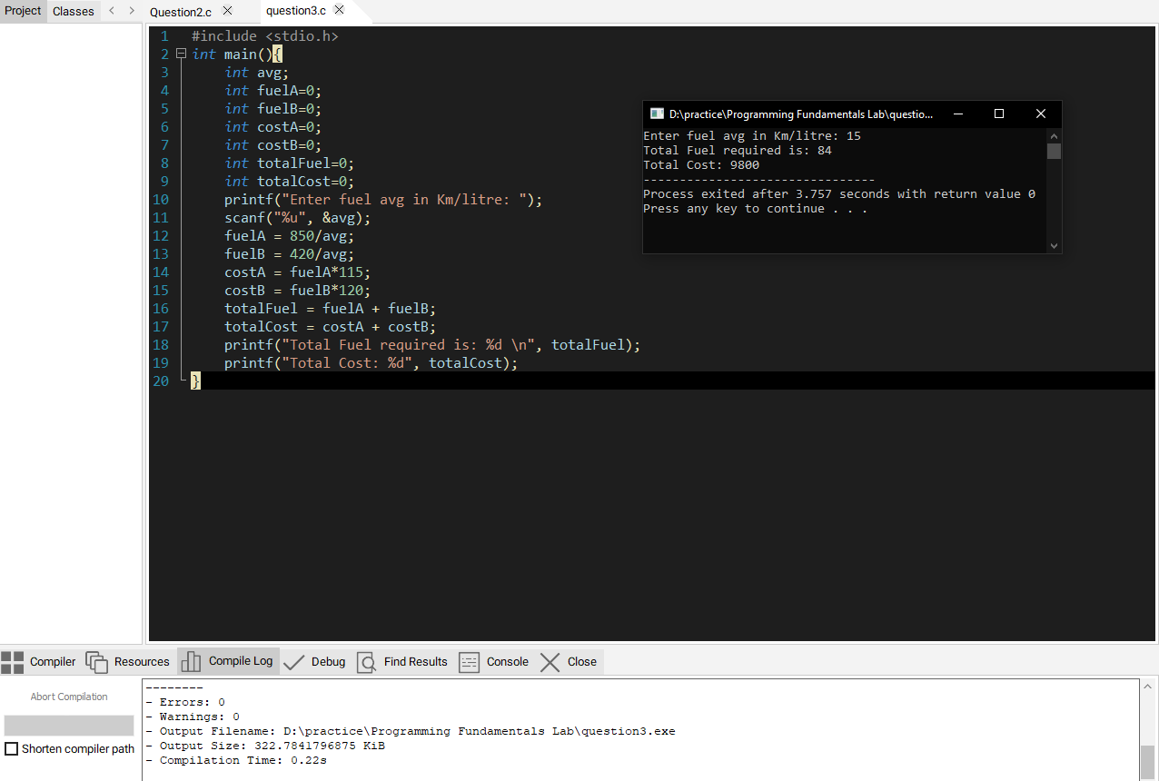

**QUESTION 4**

**QUESTION 5**

